Chapter 2 Specification Requirement

2.1 Use Case Scenario

2.1.1 Feature 1

2.1.1.1 Actor


2.1.1.2 Use Case Diagram
Feature 1: Daily Briefing System
Feature 1 provides a Daily Briefing System that periodically crawls a predefined list of approved Thai government and mainstream media websites (for example, Bangkok Post and The Nation Thailand) and stores each discovered article as one Daily Briefing item in the news database. Each Daily Briefing item contains the original title, a short system-generated news summary, the source website name, the original article URL, the publication date provided by the source, and a crawl time(Every morning at eight o 'clock ), which records the exact time when the system fetched this article. For every stored item, the system also generates Chinese and English translations of the title and summary, so that the item has two language versions internally while the interface only shows one language at a time according to the user’s current language setting.
Use case UC‑01 “Browse Daily Briefing” lets International Student open the Daily Briefing page and receive a paginated list of recent Daily Briefing items ordered from newest to oldest by publication date. On this list page, each item shows the title, summary, news source name and publication date in the current interface language only (either Chinese or English), and provides a button to open the detail view.
Use case UC-02 “View News Details” allows International Student to select one Daily Briefing item and open a detail view page that displays the title, summary, source website name, publication date . All these fields are shown in the current interface language only, and the values are taken from the corresponding Chinese or English translation of that Daily Briefing item.
Use case UC-03 “Search News” provides keyword-based retrieval over the titles and summaries of all Daily Briefing items in both Chinese and English versions stored in the database. International Student enters Chinese or English keywords in the search box, and the system returns a filtered list of items whose stored titles or summaries (English and Chinese) contain the keywords, but the results are still displayed to the user in the current interface language only.
Use case UC‑04 "Jump to Original Link" supports direct navigation from the daily briefing list or news detail view to the full article on the external official website. After clicking the "View Original" button, the original article URL of the selected item will open in a new browser TAB.
Use case UC-05 “Filter News” lets International Student narrow the Daily Briefing list by specifying structured criteria, including at least a start date and end date, and one or more news sources selected from the predefined list of Thai official and media websites. The system applies these filters to the news dataset and only shows Daily Briefing items that satisfy all selected conditions.
Use case UC‑06 “Switch Interface Language” allows International Student to toggle the interface between Chinese and English at any time by clicking a language switch button. After the language is switched, the Daily Briefing System reloads all interface texts and, for every Daily Briefing item shown on the page, selects and displays only the corresponding Chinese or English translation of the title and summary.
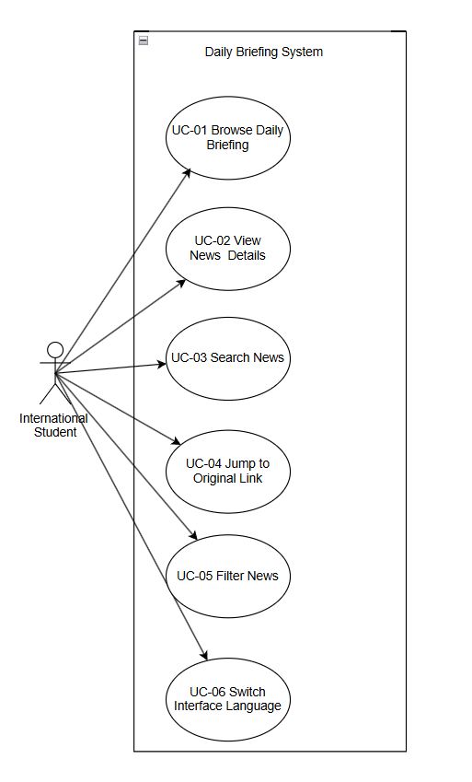

2.1.2 Feature2

2.1.2.1 Actor


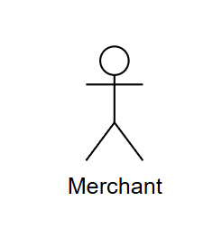

2.1.2.2 Use Case Diagram
Feature 2: Community Interaction
Feature 2 provides a community and messaging space where International Students can publish English/Chinese posts, interact through likes and comments, and send private messages to mutual‑follow partners. A community post contains a title and body text in Chinese or English, optional images, and tags selected from a predefined list such as “Study”, “Travel” and “Part‑time Job”. A mutual‑follow relationship exists when two International Students have both followed each other, which allows them to appear in each other’s mutual‑follow list and to start private conversations.
Use case UC‑07 “Browse Community Feed” lets International Students and Merchant open the community page and view a continuously updated feed of approved community posts authored by International Students and Merchant. The Post is ordered from newest to oldest by publication time, and as International Students/Merchant scroll down, more posts are loaded. Each post card in the feed shows the title, a short preview of the body text, selected tags, basic engagement metrics (like count and comment count)
Use case UC‑08 “Create/Edit/Publish Post” enables International Students and Merchant to create a new community post or edit one of their existing posts. International Students can enter the post title and body in either Chinese or English, upload images and choose tags (such as Learning) from the predefined tag list. When International Students submit the post for publishing, the system invokes AI‑based translation to generate the other language version of the title and body, and runs content moderation checks. The post is published to the community feed only after it satisfies the safety rules (not breaking the law) defined by the moderation process.
Use case UC‑09 “Like Post” lets International Students express positive feedback on a specific community post by clicking a like button.
Use case UC‑10 “Filter by Tag” allows International Students to focus on posts belonging to specific topics by selecting tags from the predefined tag list (for example “Study”, “Housing”, “Travel”, “Part‑time Job”). After tags are selected, the community feed only shows posts that contain at least one of the selected tags.
Use case UC‑11 “View Post Details” allows International Students and Merchant to open a single community post from the feed and see the full body text, all images, the tags(such as Learing), detailed engagement metrics (total likes and total comments), the moderation status and a link to the author’s profile.
Use case UC‑12 “Report Post/Comment” allows International Students/Merchant to submit structured reports about suspected spam, fraud, illegal service promotion or abusive language on a specific community post or comment. International Students/Merchant choose one or more predefined report reasons, such as “Spam”, “Fraud or Scam”, “Illegal Service Promotion”, “Abusive Language” or “Other”, and can optionally enter additional description text before sending the report for later moderation.
Use case UC‑13 “Post Comment” enables International Students and Merchant to add comments under a selected community post. International Students/Merchant can enter the comment text in Chinese or English and submit it, after which the new comment appears in the comment list below the post together with the commenter’s name and timestamp.
Use case UC‑14 “Search Posts” offers full‑text search across the titles and body texts of all community posts in Chinese and English. International Students/Merchant can enter keywords. The system returns community feed that lists only posts matching the search query.
Use case UC‑15 “Communicate with Mutual‑Follow Partners” allows International Students and Merchant to communicate privately with accounts on their mutual‑follow list. International Students and Merchant can open an existing one‑to‑one conversation or create a new conversation with a mutual‑follow partner, send and receive messages, and view the conversation history in a chat interface.
Use case UC‑16 “Manage Message Status” lets International Students and Merchant manage the status of their messages and conversations. International Students and Merchant can mark conversations as read or unread, and they can delete an entire conversation from their own conversation list so that it no longer appears in the chat overview.
Use case UC‑17 “View and Manage Mutual‑Follow List” enables International Students and Merchant to open a dedicated mutual‑follow list page that shows all accounts that have established a mutual‑follow relationship with the current account. From this page, International Students can search within their mutual‑follow partners, open a partner’s profile, remove the follow relationship or start a private conversation with a selected partner.
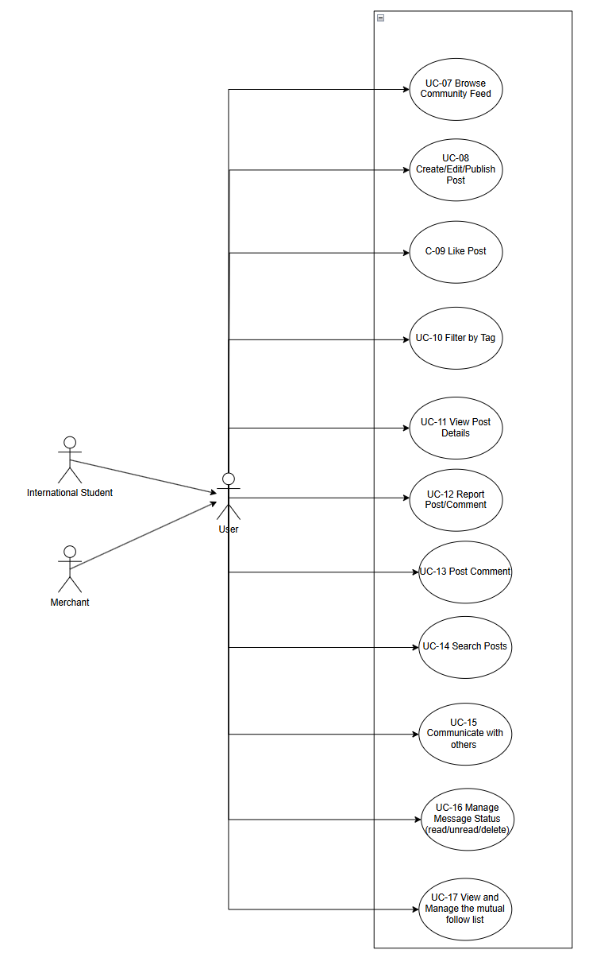

2.2.3 Feature 3

2.2.3.1 Actor




2.2.3.2 Use Case Diagram
Feature 3: Authentication and Profile System
Feature 5 provides an authentication system that enables International Students and Merchant to register new accounts using different registration methods, log in to access the system, and manage their personal profile information. A user account contains at least a unique identifier (school email address for International Students or phone number for Merchant), a password, a display name, an optional avatar image, a preferred interface language (Chinese or English)
Use case UC‑18 “Register Account” allows new users to create an account, but the registration process differs for International Students and Merchant. For International Students, they must register using a school email address (for example, an email address ending with .edu). International Students enter their school email address, and the system sends a verification code to that email address. International Students enter the received verification code, set a password, choose a display name, and select their preferred interface language to complete registration. For Merchant, they must register using a phone number. Merchants enter their phone number, and the system sends a verification code via SMS to that phone number. Merchants enter the received verification code, set a password, choose a display name, and select their preferred interface language to complete registration. After International Students or Merchant submit all required information and the verification code is validated, the system creates a new user account in the database.
Use case UC‑19 “Log In” enables International Students and Merchant to access the system by entering their registered school email address (for International Students) or phone number (for Merchant) and password.
Use case UC‑20 “Log Out” allows logged‑in International Students and Merchant to end their current session by clicking a logout button, after which they are redirected to the login page and must log in again to access the system.
Use case UC‑21 “View/Edit Profile” enables International Students and Merchant to open their personal profile page and view their stored account information, including display name, avatar, preferred interface language . International Students and Merchant can edit any of these fields by entering new values and submitting the changes, and the system saves the updated information to the user database.
Use case UC‑22 “View My Community Posts” provides International Students and Merchant with a dedicated list page showing all community posts authored by their current account. International Students and Merchant can see each post’s title, publication time and current moderation status (published, pending review, or rejected) on this list page.
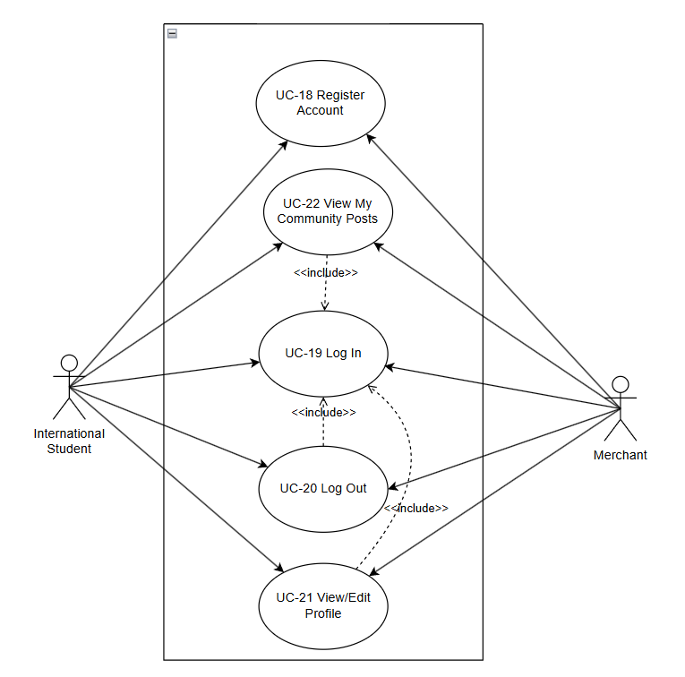

2.2 User Requirement Specification
Feature 1:
URS-01 – Browse Daily Briefings
International Students can open the Daily Briefing page and browse a paginated list of recent Daily Briefing items in their current interface language.
URS-02 – View news details
International Students can select a Daily Briefing item from the list and view a news detail page that shows the complete information for that item in their current interface language.
URS-03 – Search for News
International Students can type Chinese or English keywords into a search box on the Daily Briefing page and view only Daily Briefing items that match the entered keywords.
URS‑04 – Jump to the original link
International Students can click an “Open original article” button on a Daily Briefing item and read the full original news article on the external official website in a new browser tab.
URS‑05 – Filter News
International Students can filter Daily Briefing items by choosing a start date, an end date, and one or more news sources from a predefined list, and then browse only the items that meet these filter conditions.
URS‑06 – Switch Interface Language
International Students can click a language switch button at any time to change the interface language between Chinese and English and continue browsing Daily Briefing items in the newly selected language.

Feature 2:
Feature 2 - Community Interaction
URS‑07 – Browse Community Feed
International Students and Merchant can open the community page and view a continuously updated feed of approved community posts authored by International Students and Merchant.
URS‑08 – Create/Edit/Publish Community Post
International Students and Merchant can create a new community post or edit one of their existing posts.
International Students and Merchant can enter the post title and body in either Chinese or English, upload images, and choose tags (such as “Learning”) from the predefined tag list.
International Students and Merchant can submit the post for publishing, and the post is published to the community feed only after it satisfies the safety rules (not breaking the law) defined by the moderation process.
URS‑09 – Like Post
International Students and Merchant can express positive feedback on a specific community post by clicking a like button.
URS‑10 – Filter by Tag
International Students and Merchant can focus on posts belonging to specific topics by selecting tags from the predefined tag list (for example “Study”, “Housing”, “Travel”, “Part‑time Job”).
After International Students and Merchant select tags, they can see the community feed showing only posts that contain the selected tags.
URS‑11 – View Post Details
International Students and Merchant can open a single community post from the feed and see the full body text, all images, the tags (such as “Learning”), detailed engagement metrics (total likes and total comments), and a link to the author’s profile.
URS‑12 – Report Post/Comment
International Students and Merchant can submit reports about suspected spam, fraud, illegal service promotion, or abusive language on a specific community post or comment.
International Students and Merchant can choose one or more predefined report reasons, such as “Spam”, “Fraud or Scam”, “Illegal Service Promotion”, “Abusive Language”, or “Other”, and can optionally enter additional description text before sending the report for later moderation.
URS‑13 – Post Comment
International Students and Merchant can add comments under a selected community post.
International Students and Merchant can enter the comment text in Chinese or English and submit it, and then they can see the new comment appearing in the comment list below the post together with the commenter’s name and timestamp.
URS‑14 – Search Posts
International Students and Merchant can search for community posts by entering keywords.
URS‑15 – Communicate with Mutual‑Follow Partners
International Students and Merchant can communicate privately with accounts on their mutual‑follow list.
International Students and Merchant can open an existing one‑to‑one conversation or create a new conversation with a mutual‑follow partner, send and receive messages, and view the conversation history in a chat interface.
URS‑16 – Manage Message Status
International Students and Merchant can manage the status of their messages and conversations.
International Students and Merchant can mark conversations as read or unread, and they can delete an entire conversation from their own conversation list so that it no longer appears in the chat overview.
URS‑17 – View and Manage Mutual‑Follow List
International Students and Merchant can open a dedicated mutual‑follow list page that shows all accounts that have established a mutual‑follow relationship with the current account.
From this page, International Students and Merchant can search within their mutual‑follow partners, open a partner’s profile, remove the follow relationship, or start a private conversation with a selected partner.
Feature 3:
URS‑18 – Register Account
International Students can create a new user account by entering their school email address (for example, an email address ending with .edu ). International Students receive a verification code sent to their school email address, enter the received verification code, set a password, choose a display name, and select their preferred interface language (Chinese or English) to complete registration.
Merchants can create a new user account by entering their phone number. Merchant receives a verification code via SMS sent to their phone number, enter the received verification code, set a password, choose a display name, and select their preferred interface language (Chinese or English) to complete registration.
URS‑19 – Log In
International Students can log in to the system by entering their registered school email address and password.
Merchants can log in to the system by entering their registered phone number and password.
URS‑20 – Log Out
International Students and Merchant can log out from the system by clicking a logout button, and then they are redirected to the login page and must log in again to access the system.
URS‑21 – View and Edit Profile
International Students and Merchant can open their personal profile page to view their stored account information, including display name, avatar, and preferred interface language.
International Students and Merchant can edit any of these profile fields by entering new values and submitting the changes.
URS‑22 – View My Community Posts
International Students and Merchant can open a dedicated list page under their profile to view all community posts created by their current account.
International Students and Merchant can see each post’s title, publication time and current moderation status (published, pending review, or rejected) on this list page.

